Virtual box provisioned with vagrant-ansible.

Install vagrant hostsupdater used to directly access virtual machines from browser.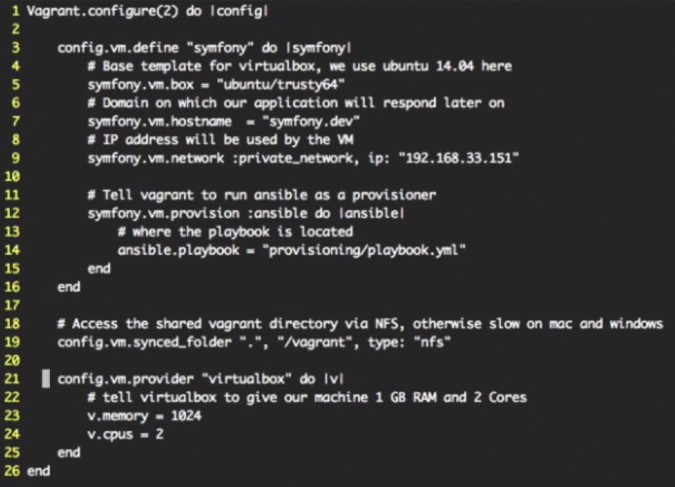

Written in ruby…Ruby syntax.

Line-3: Calling Vm as symphony

5.) Base box we use is Ubuntu

13.) Tell vagrant to use ansible as provisioner